EXPERIMENT-1
NAME: Yuvaraj A ROLL NO:240701809

USER INTERFACE AND DESIGN
COMAPARSION OF UI DESIGN BETWEEN TWO FIGMA CREATION
BAD WEBSITE:
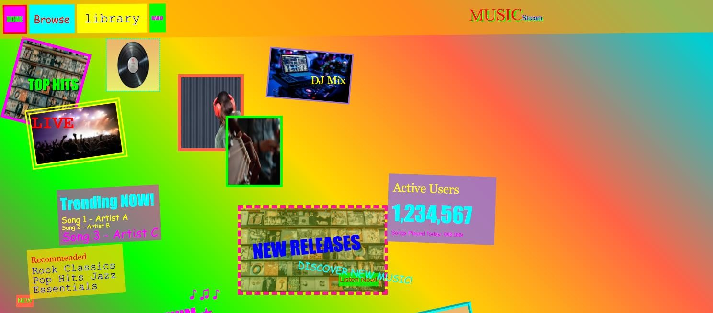
GOOD WEBSITE:
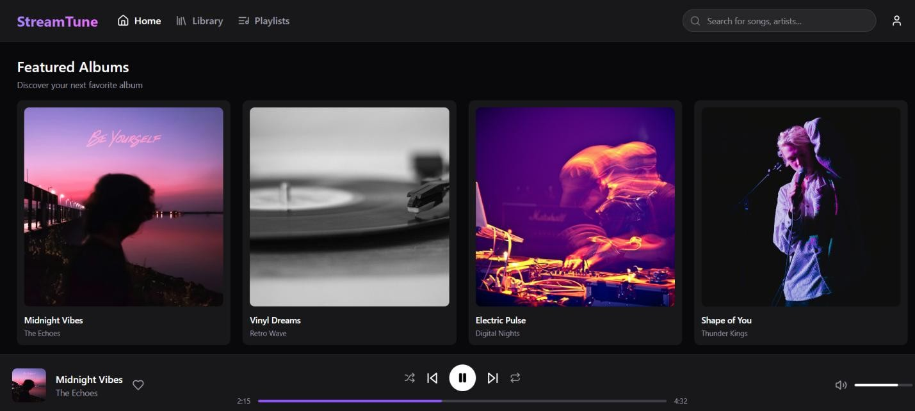

PROTOTYPE LINK:
https://rouge-five-01943104.figma.site/

Comparison of UI Design Between Two Music Streaming Websites

BAD WEBSITE (Confusing Music UI)

- Design Style:
  - Bright and clashing color combinations such as green, yellow, blue, and pink.
  - Overcrowded and cluttered layout with no proper alignment.
  - Inconsistent font styles, sizes, and orientations.
  - Random placement of images and text without a grid structure.

- Content:
  - Displays many elements such as trending music, recommendations, playlists, and user statistics on a single screen.
  - Text overlaps with images in some areas, reducing readability.
  - Content appears scattered and lacks proper grouping.

- Navigation:
  - Navigation options like Browse, Library, Search, and Profile are poorly placed.
  - No clear visual distinction between navigation elements and content.
  - Users may struggle to locate important features quickly.

- Purpose:
  - Intended for music browsing and streaming.
  - Fails to deliver a smooth user experience due to poor organization and visual overload.

GOOD WEBSITE (Well-Designed Music Streaming UI)

- Design Style:
  - Clean, modern, and visually balanced layout.
  - Uses a consistent dark theme suitable for music streaming platforms.
  - Proper spacing, alignment, and grid-based structure.
  - Uniform typography with clear headings and readable text.

- Content:
  - Displays albums, playlists, and recommendations in a well-organized manner.
  - Clear separation between sections such as Trending Music, Playlists, and Player Controls.
  - Minimal text with clear emphasis on album artwork.

- Navigation:
  - Clearly visible navigation bar placed at the top or side.
  - Icons and labels are easy to understand.
  - Smooth and intuitive user flow between different sections.

- Purpose:
  - Designed to enhance user engagement and listening experience.
  - Helps users quickly find, play, and manage music.

KEY DIFFERENCES

  - Focus: The bad website lacks structure and clarity, while the good website focuses on usability and simplicity.

  - Design Aesthetics: The bad website uses excessive and mismatched colors, whereas the good website maintains a consistent and professional theme.

  - Content Organization: Content in the bad website is cluttered; the good website organizes content logically with clear hierarchy.

  - User Experience: The bad website creates confusion and frustration. The good website provides a smooth, enjoyable, and user-friendly experience.

  - Target Audience: The bad website may confuse first-time users. The good website is designed for regular users who want easy and quick access to music.

